**Internal Consistency Measurement**

Internal consistency is typically a measure based on the [correlations](https://en.wikipedia.org/wiki/Correlation) between different items on the same test (or the same subscale on a larger test). It measures whether several items that propose to measure the same general construct produce similar scores. For example, if a respondent expressed agreement with the statements "I like to ride bicycles" and "I've enjoyed riding bicycles in the past", and disagreement with the statement "I hate bicycles", this would be indicative of good internal consistency of the test.

Internal consistency is usually measured with Cronbach's alpha, a statistic calculated from the pairwise correlations between items. Internal consistency ranges between negative infinity and one.

Cronbach’s Alpha is a measure of reliability of the degree to which different items in an instrument are correlated and measure a single engagement principle otherwise known as internal consistency. While there is no clear threshold, it is widely accepted that in the early stages of validation research α should exceed 0.70 to show internal consistency.

Coefficient alpha will be negative whenever there is greater within-subject variability than between-subject variability. A commonly accepted rule of thumb for describing internal consistency is as follows:

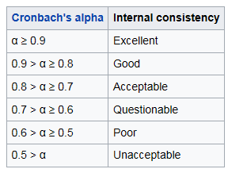

Weighted scores for each specific item are also obtained by factorial analysis or principal component analysis.

**\* Satisfaction with treatment plan (p. 3 patient survey);**

ptsumsattxplan= sum(xpt_sat_treatment_plan, xpt_sat_treatment_compl);

The internal consistency check on this variable is good. The Cronbach coefficient alpha is greater than 0.8 and kappa test is also significant.

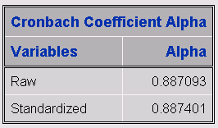

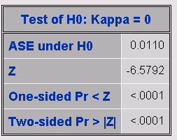

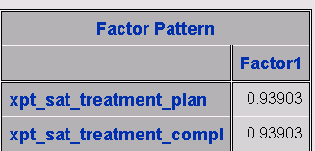

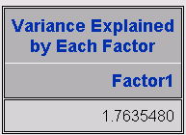

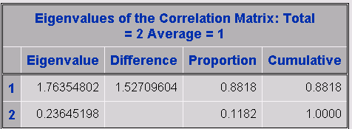

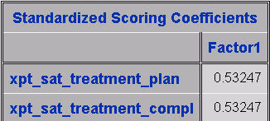

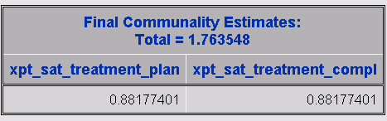

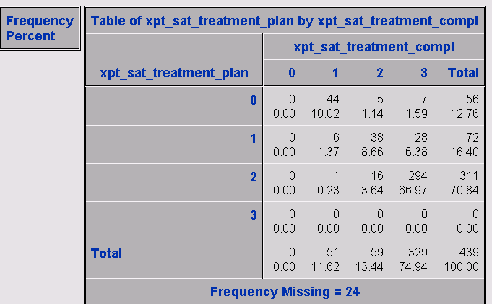

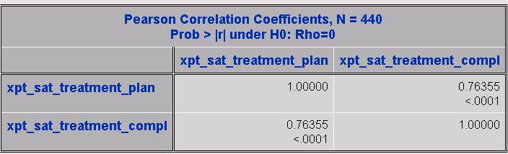

**\* Barriers to completing treatment plan (p. 4 patient survey);**

**sumbarriers= sum(xpt_issues_a, xpt_issues_b, xpt_issues_c, xpt_issues_d, xpt_issues_e, xpt_issues_f, xpt_issues_g, xpt_issues_h);**

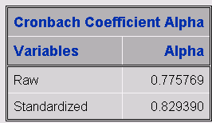

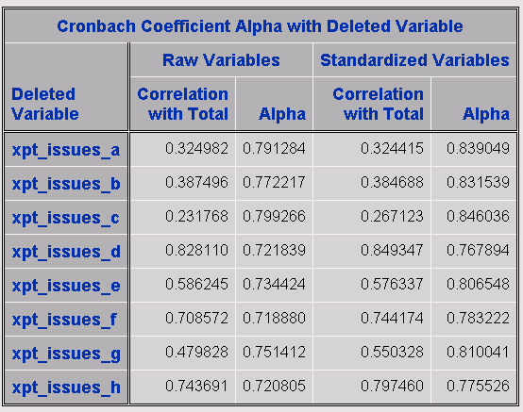

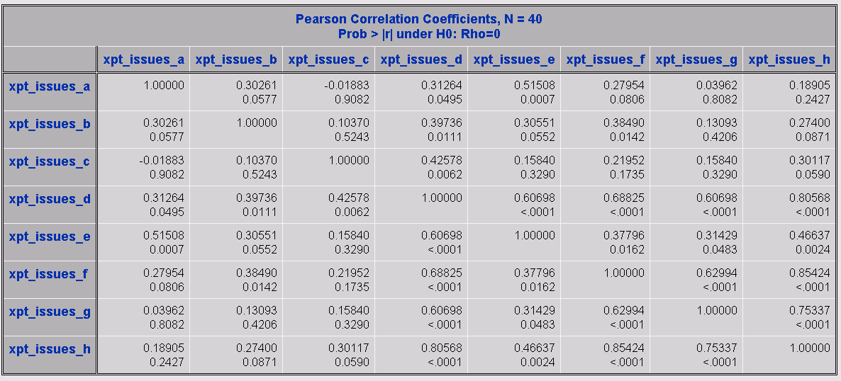

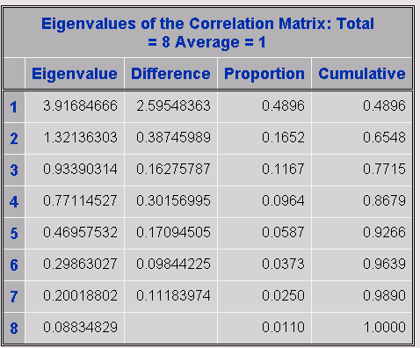

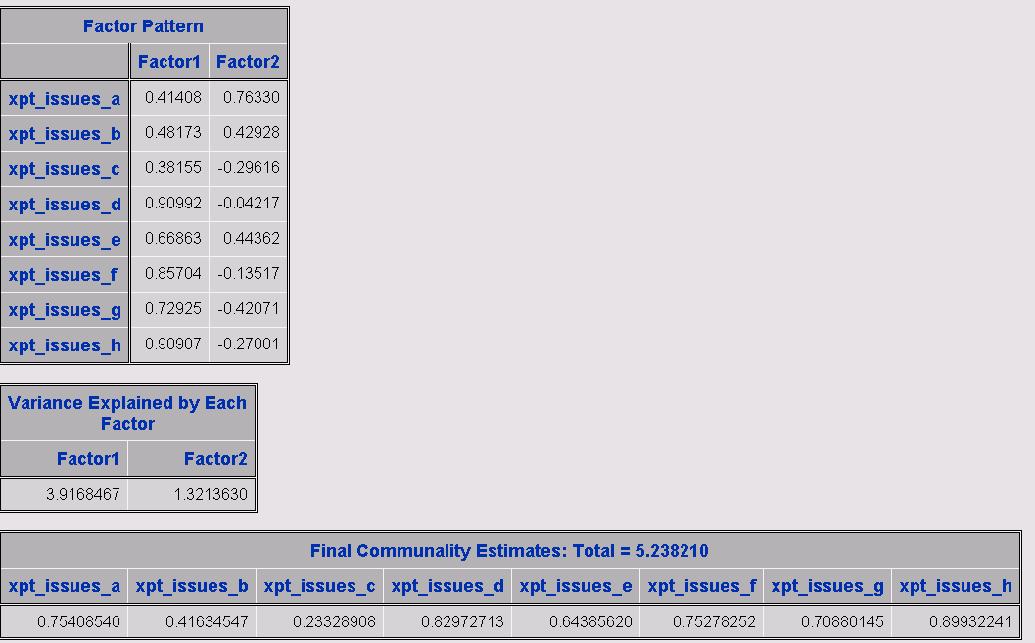

**\* Satisfaction with quality of care from various team members (p. 4 patient survey);**

sumsatqc= sum(xpt_sat_care_pcc, xpt_sat_care_onc, xpt_sat_care_pulm, xpt_sat_care_surgeon, xpt_sat_care_nurse_nav, xpt_sat_care_other_nurses, xpt_sat_care_nonclinic, xpt_sat_care_whole_team);

The Cronbach coefficient alpha for this item is lower than 0.7 indicating that this item measurement is questionable. The xpt_sat_care_surgeon has negative correlation with total

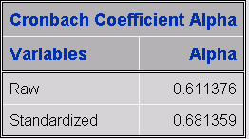

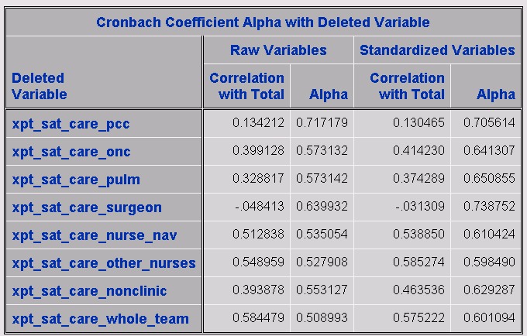

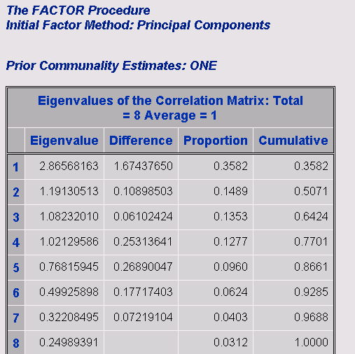

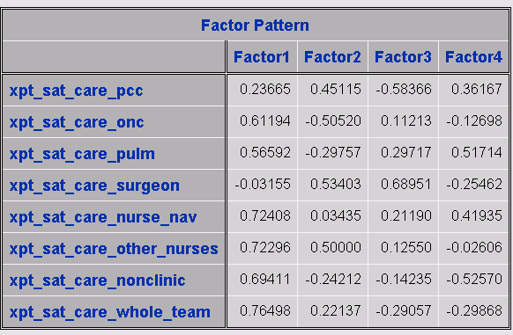

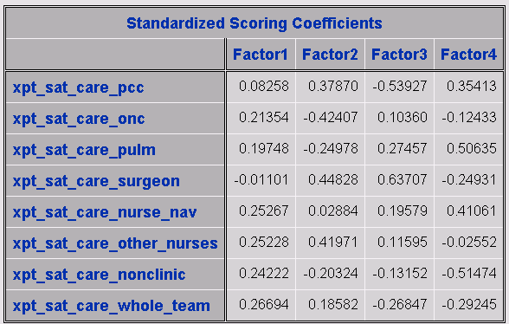

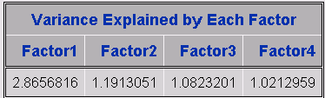

Removing the variable xpt_sat_care_pcc increases the standardized Cronbach coefficient alpha to an acceptable value of 0.709306.

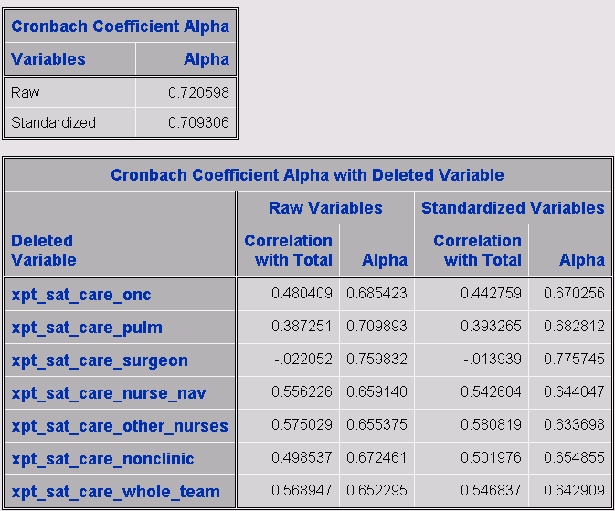

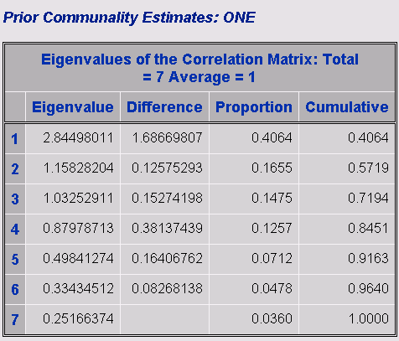

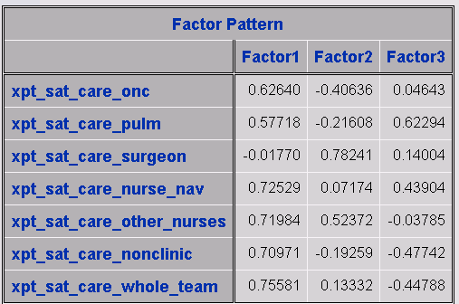

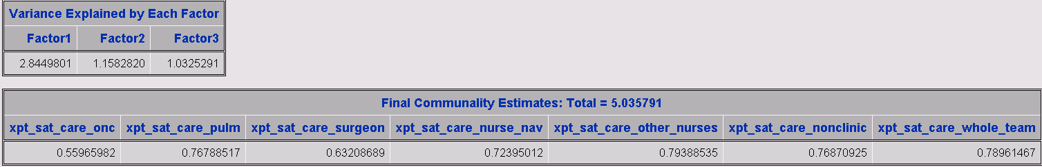

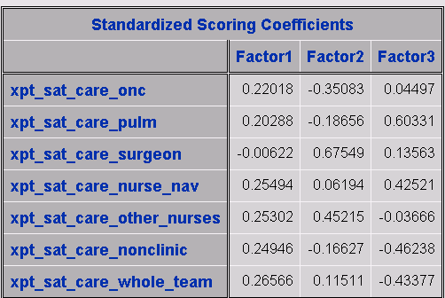

Removing the variable xpt_sat_care_surgeon increases the standardized Cronbach coefficient alpha to an acceptable value of 0.719669.

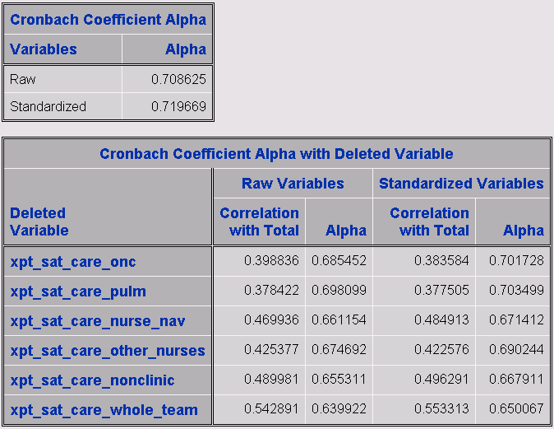

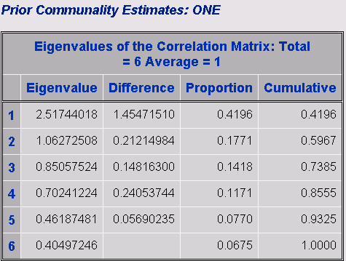

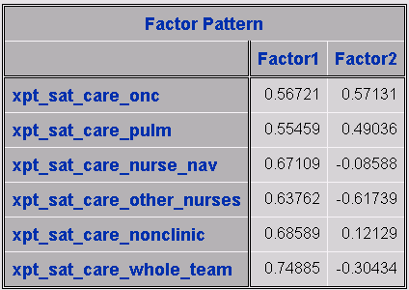

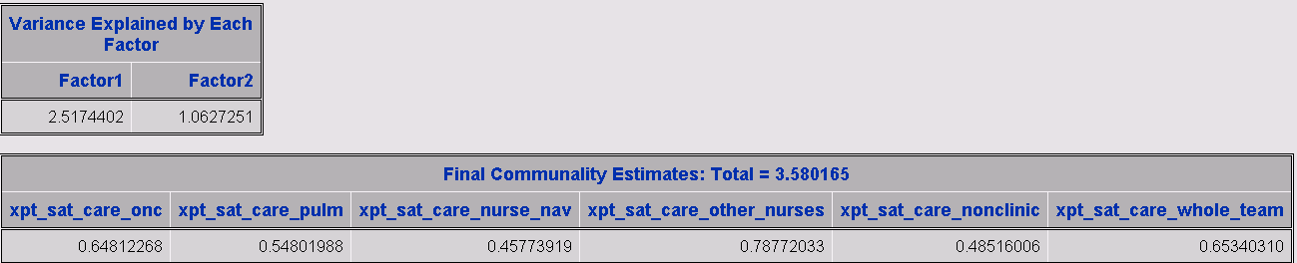

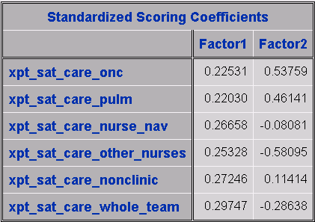

**\* CAHPS items – Physician communication – 5 item version (p. 5 patient survey);**

sumphyscomm7= sum(xpt_exp_phys_listen, xpt_exp_phys_explain, xpt_exp_phys_tx_inform,

xpt_exp_phys_encourage, xpt_exp_phys_respect, xpt_exp_phys_helpful, xpt_exp_phys_aware);

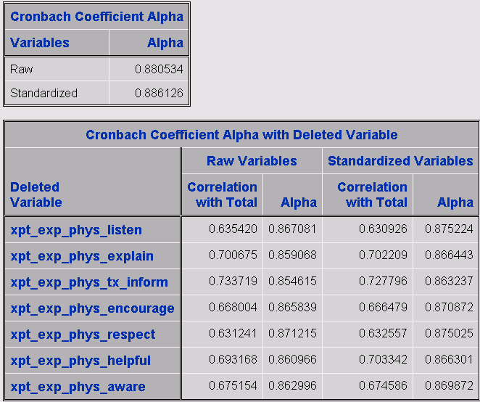

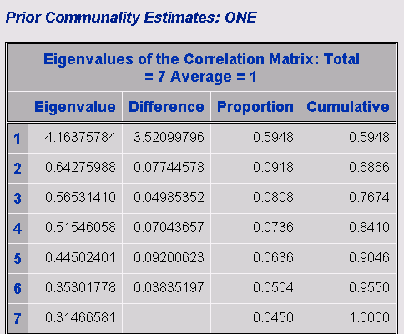

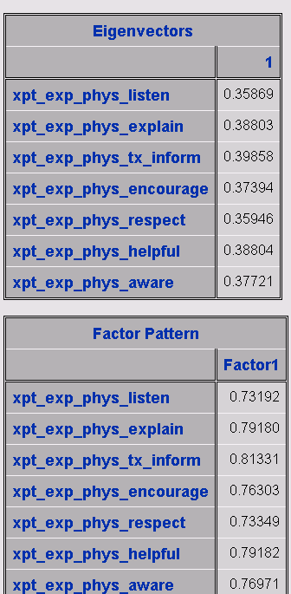

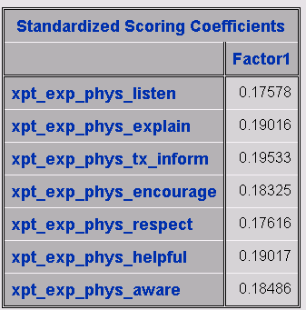

**\* We created a 6-item nurse communication measure based on the CAHPS Physician Communication items (pp 5-6 patient survey);**

sumnursecomm= sum(xpt_exp_nurse_listen, xpt_nurses_often_explain, xpt_nurses_often_info, xpt_nurses_often_encourage, xpt_nurses_often_treat,

xpt_nurses_often_help);

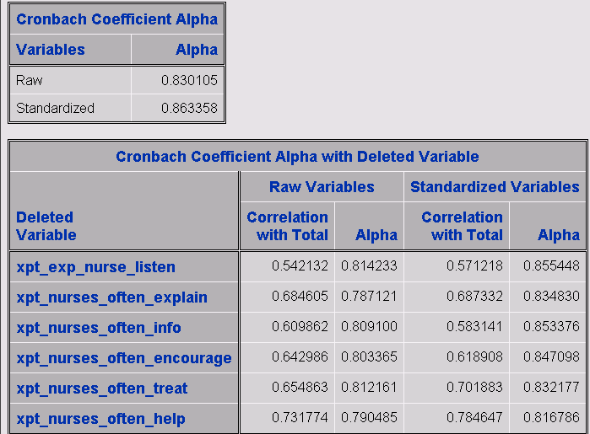

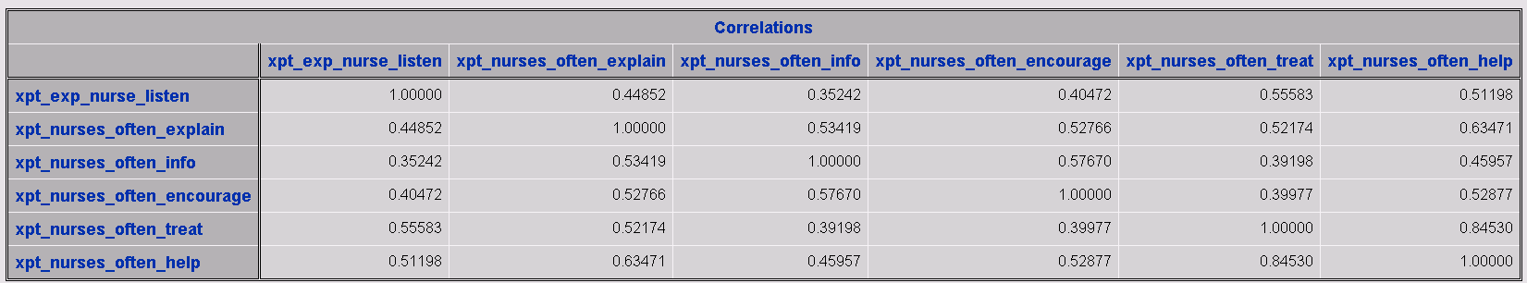

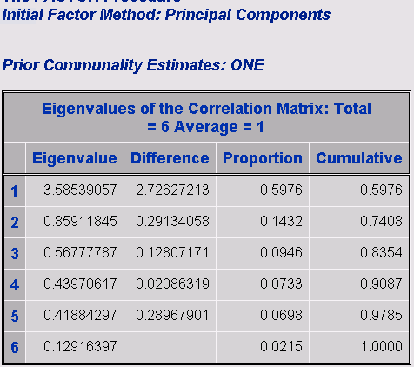

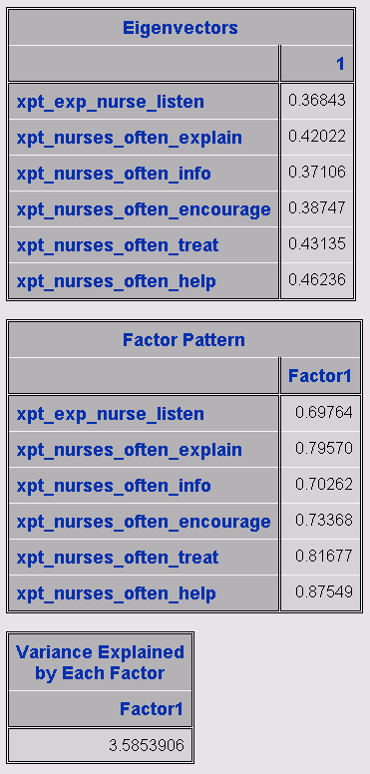

**/* 4 items (p. 6 of patient survey) plus 1 item (item 7 on p. 7 patient survey) ask about satisfaction with care from the team as a whole; */**

sumteamsat= sum(xpt_nurses_often_handle, xpt_nurses_often_team,

xpt_nurses_often_discomfort, xpt_nurses_often_understand, xpt_inform_all_they_could);

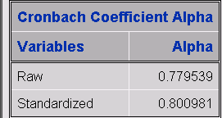

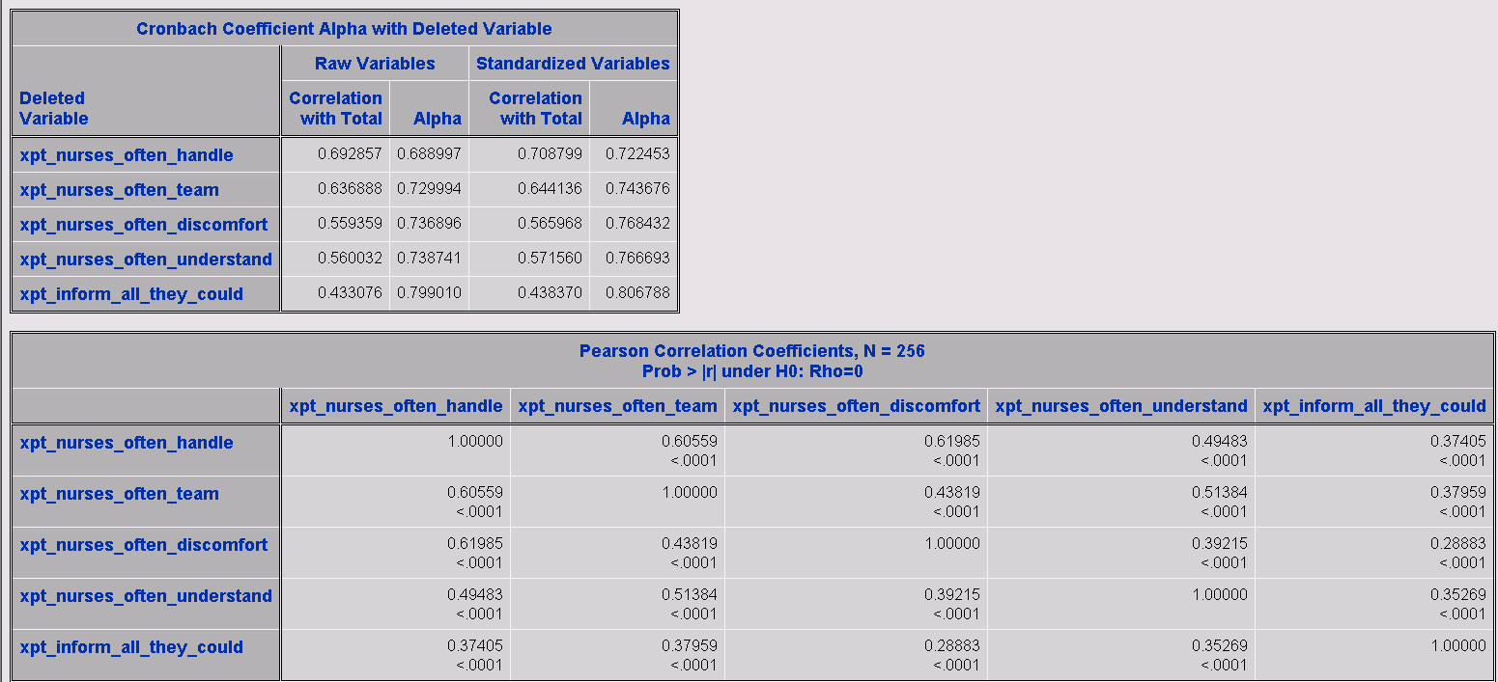

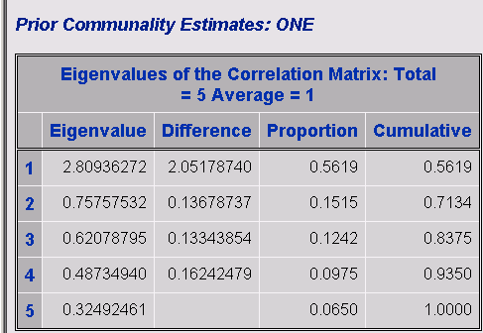

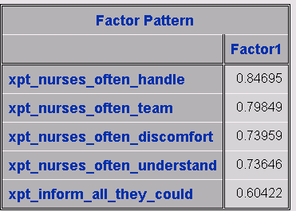

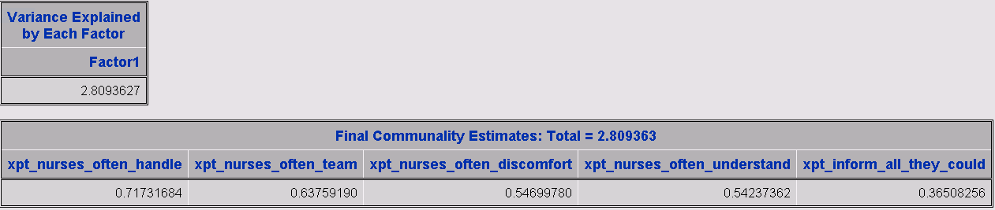

**\* Communication about disease-specific information;**

sumptinfo= sum(xpt_inform_diagnosis, xpt_inform_tx_options, xpt_inform_cure_chance, xpt_inform_life_expectancy, xpt_inform_palliative_care, xpt_inform_end_of_life);

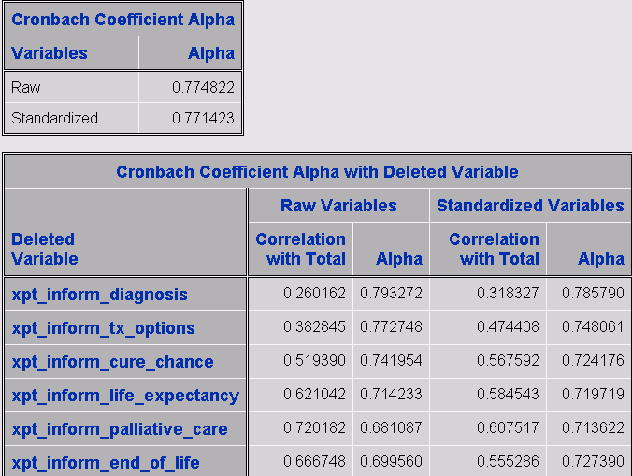

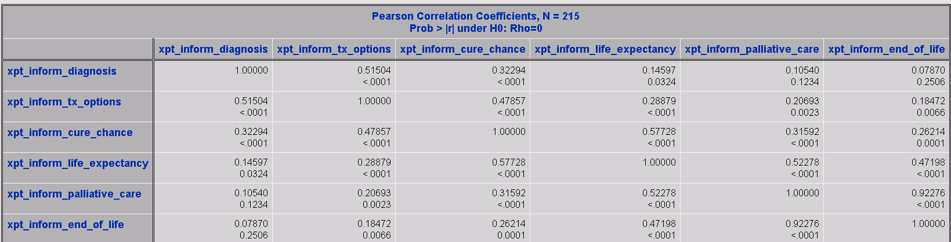

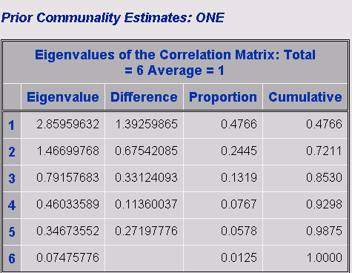

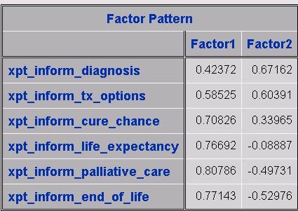

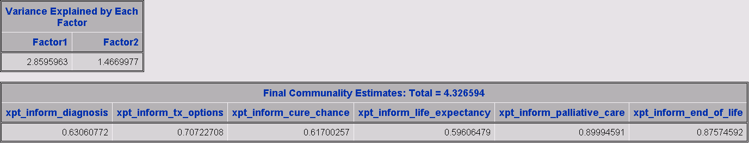

**\* Functional Assessment of Cancer Therapy – Lung (FACT-L) – Version 4;**

*create the 5 sub-scales;

**\* Physical well-being (PWB) sub-scale;**

PWB= sum(xpt_factl1, xpt_factl2, xpt_factl3, xpt_factl4, xpt_factl5, xpt_factl6, xpt_factl7);

* Social well-being (SWB) sub-scale;

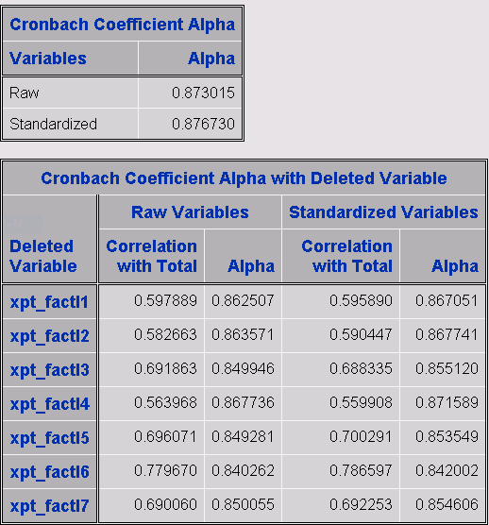

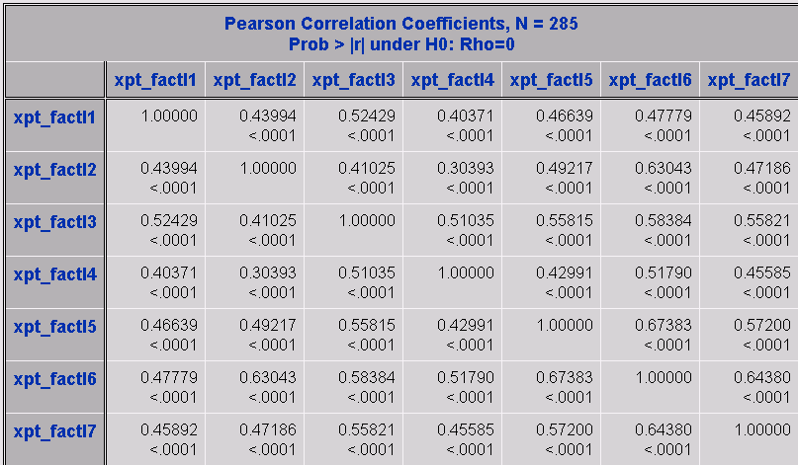

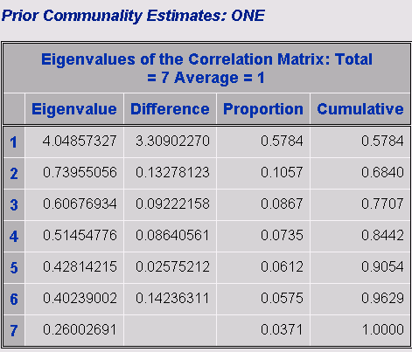

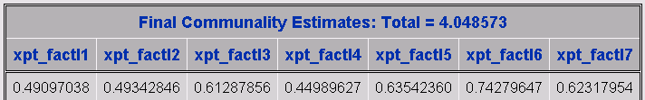

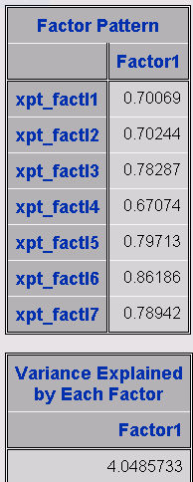

**\* Social well-being (SWB) sub-scale;**

SWB= sum(pt_factl8, pt_factl9, pt_factl10, pt_factl11, pt_factl12, pt_factl13, pt_factl14);

* Emotional well-being (EWB) sub-scale;

**pt_factl12 and pt_factl13 all missing values , pt_factl14 has missing values**

**\* Emotional well-being (EWB) sub-scale;**

EWB= sum(xpt_factl15, pt_factl16, xpt_factl17, xpt_factl18, xpt_factl19, xpt_factl20);

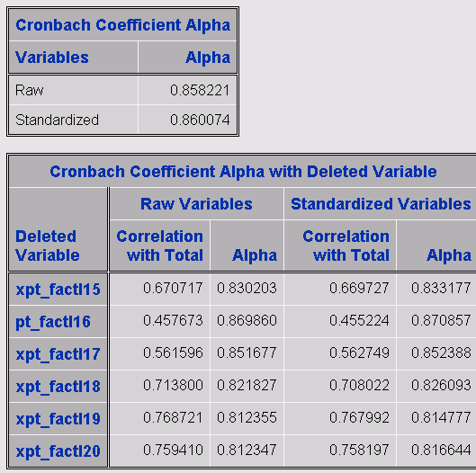

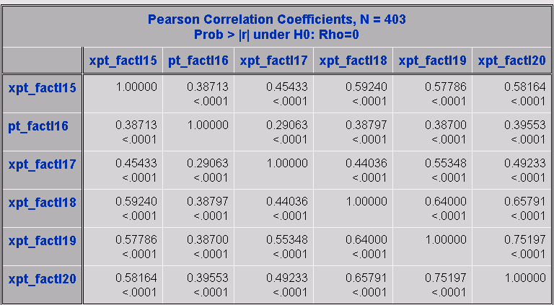

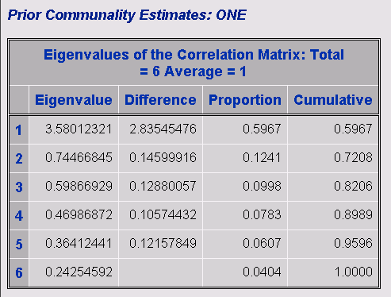

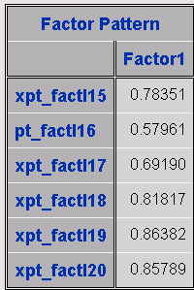

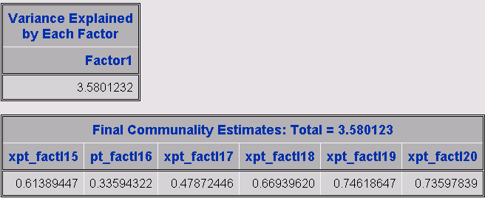

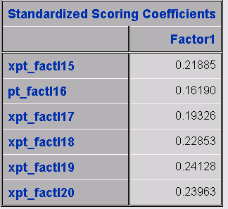

**\* Functional well-being (FWB) sub-scale;**

FWB= sum(pt_factl21, pt_factl22, pt_factl23, pt_factl24, pt_factl25, pt_factl26, pt_factl27);

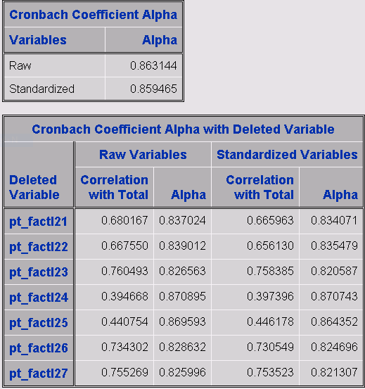

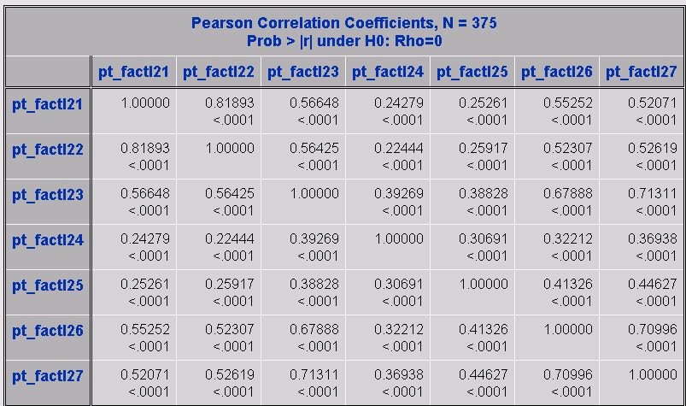

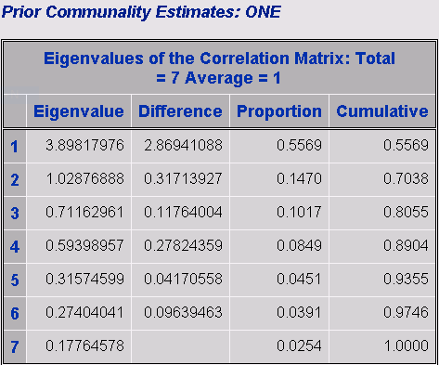

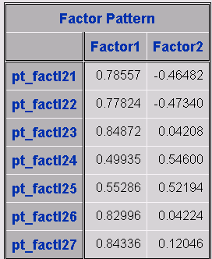

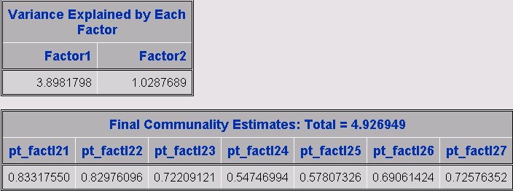

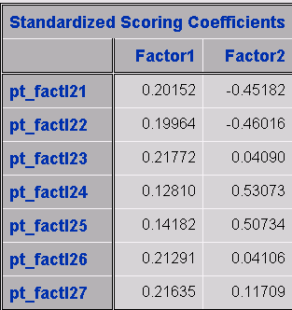

* **Lung cancer scale (LCS) sub-scale;**

LCS= sum(xpt_factl28, xpt_fctl_29, pt_fctl_30, xpt_fctl_31, xpt_fctl_32, pt_fctl_33, xpt_fctl_34, pt_fctl_35, pt_smoking_regret);

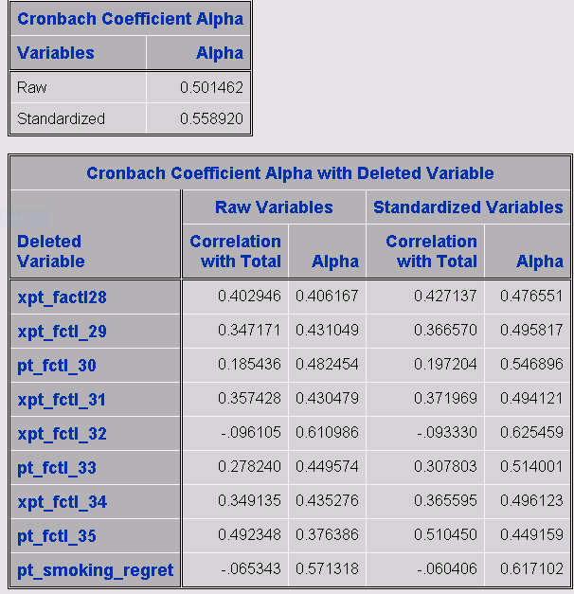

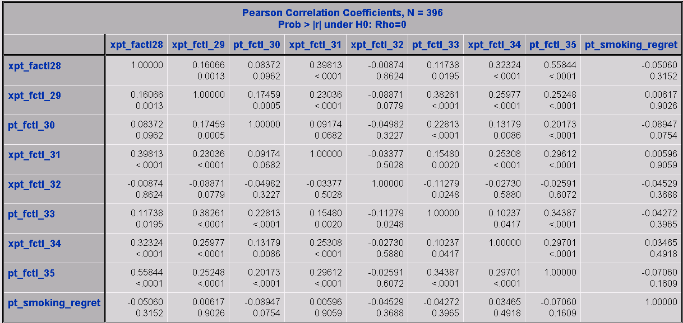

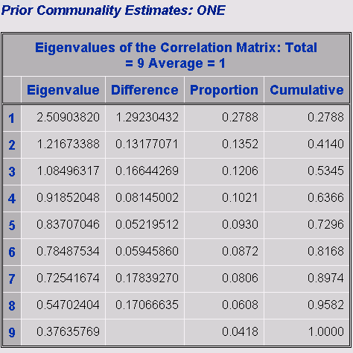

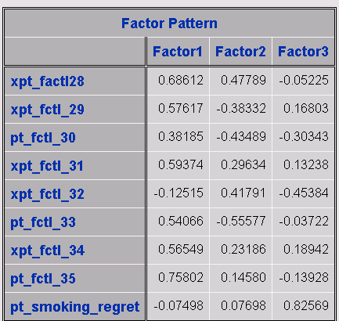

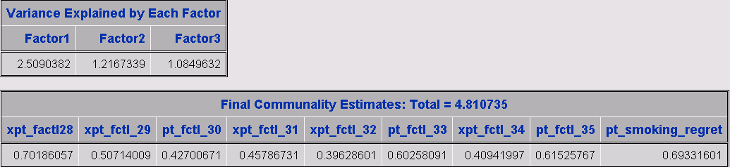

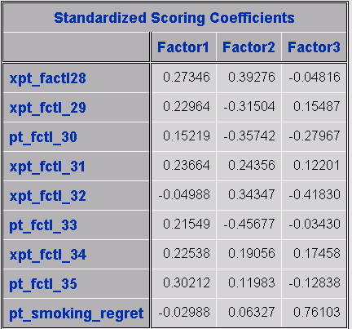

The Cronbach coefficient alpha is very much less 0.7 which indicates this variable is very poor. Removing the two items with negative correlations (xpt_fctl_32 and pt_smoking_regret) increases the Cronbach coefficient alpha to nearly 0.7 which is still questionable.

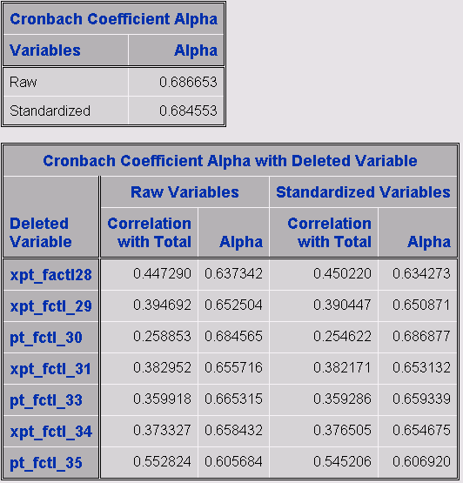

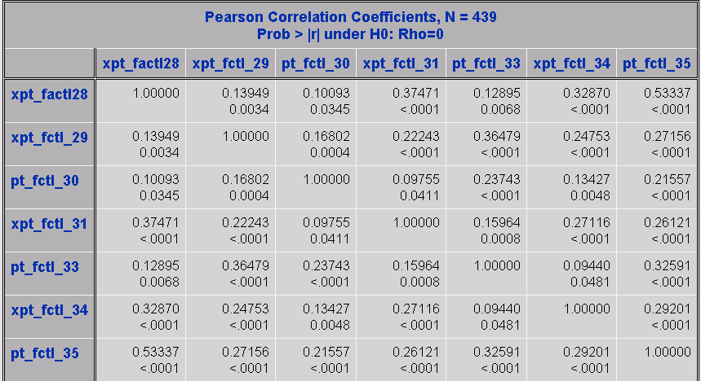

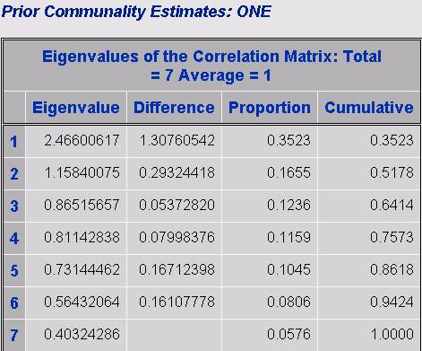

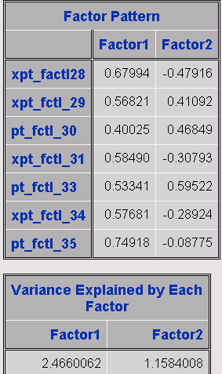

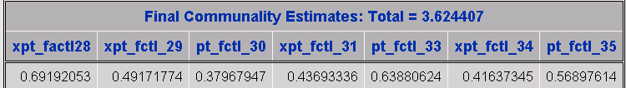

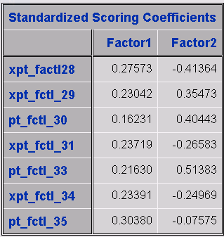

**\* Hospital Anxiety and Depression Scale (HADS; Zigmond & Snaith, 1983)**

HADS_d has all observations missing.

**\* Financial burden of medical care;**

Financialburden= sum(pt_burden_past_12, pt_burden_paid_off, pt_burden_not_paid);

End;

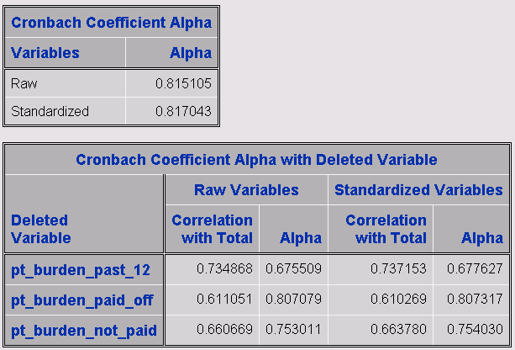

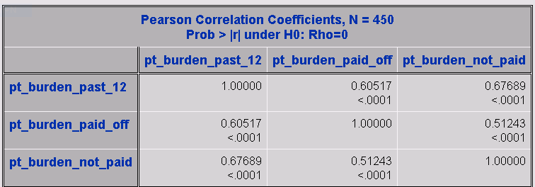

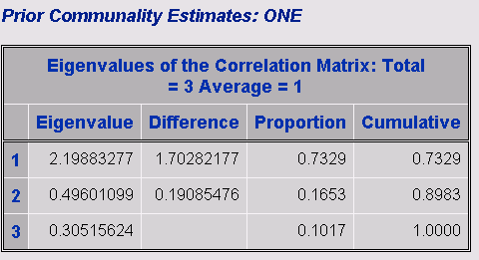

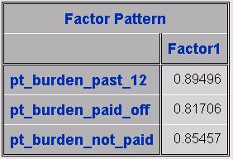

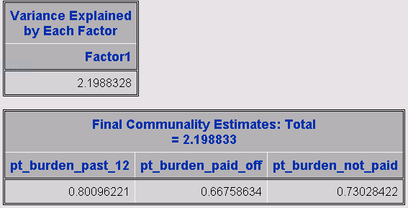

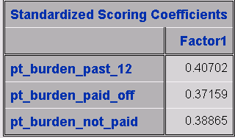

**\* Barriers to completing treatment plan (pp 3-4 caregiver survey);**

sumcgbarriers= sum(cg_issues_a, cg_issues_b, cg_issues_c, cg_issues_d, cg_issues_e, cg_issues_f, cg_issues_g, cg_issues_h);

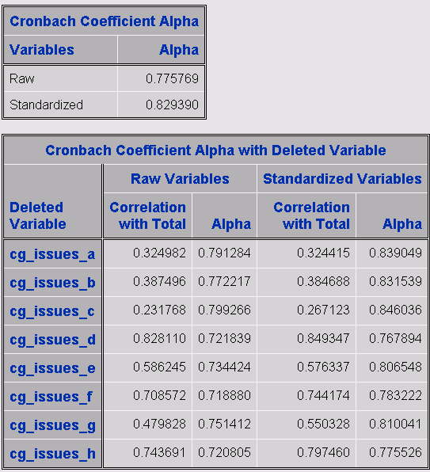

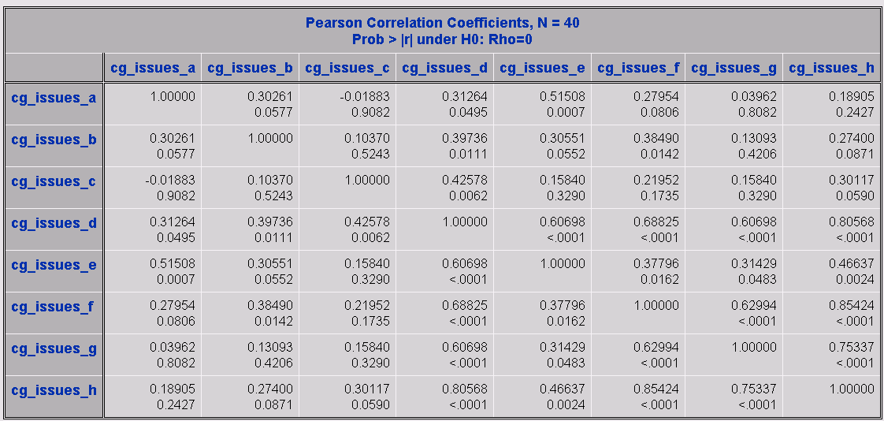

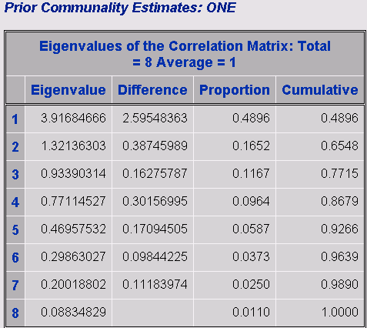

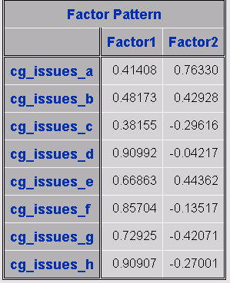

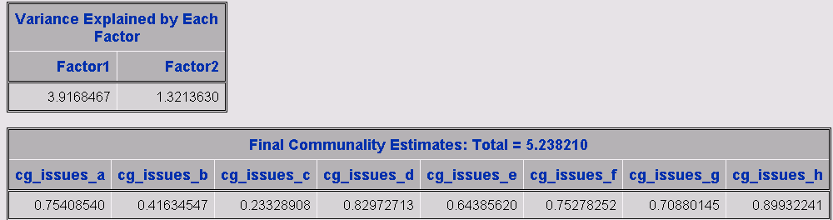

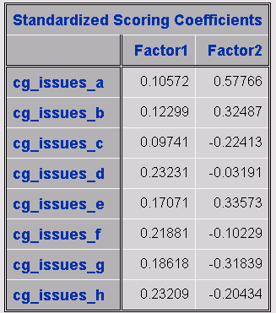

**\* Communication about disease-specific information (p 4 caregiver survey);**

sumcginfo= sum(xcg_inform_diagnosis, xcg_inform_tx_options, xcg_inform_cure_chance, xcg_inform_life_expectancy,

xcg_inform_palliative_care, xcg_inform_end_of_life)

missing observations

**\* Satisfaction with quality of care from various team members (p. 4 patient survey);**

* create sum score for overall satisfaction with quality of care;

sumcgsatqc= sum(xsat_caregiver_pc, xsat_caregiver_onc, xsat_caregiver_pulmo, xsat_caregiver_surg, xsat_caregiver_nurse, xsat_caregiver_nav, xsat_caregiver_other_staff, xsat_caregiver_whole);

missing observations

**\* CAHPS items – Physician communication – 5 item version (p. 5 caregiver survey)**

*sumcgphyscomm5= sum(xcaregiver_pt_1, xcaregiver_pt_2 xcaregiver_pt_3,

xcaregiver_pt_4, xcaregiver_pt_5)

too many missing observations

**\*\* CAHPS items – Physician communication – 7 item version (p. 5 patient survey)**

sumcgphyscomm7= sum(xcaregiver_pt_1, xcaregiver_pt_2 xcaregiver_pt_3,

xcaregiver_pt_4, xcaregiver_pt_5, xcaregiver_pt_6, xcaregiver_pt_7)

too many missing observations

**\* We created a 6-item nurse communication measure based on the CAHPS Physician Communication items (pp 5-6 caregiver survey);**

sumcgnursecomm= sum(xcg_careteam_8, xcg_careteam_9, xcg_careteam_10, xcg_careteam_11, xcg_careteam_12, xcg_careteam_13);

missing observations

**Items about satisfaction with care from the team as a whole (pp 10-11 caregiver survey)**

sumcgteamsat= sum(xcaregiver_often_14, xcaregiver_often_15, xcaregiver_often_16

sumcgteamsat= sum(xcaregiver_often_14, xcaregiver_often_15, xcaregiver_often_162

missing observations

**Caregiver Burden: 14-item Brief Assessment Scale for Caregivers (BASC) (pp 6-7 caregiver survey)**

basc= sum(xqol_caregiver_worried, xqol_caregiver_illness, xqol_caregiver_upset,

xqol_caregiver_overwhelmed, xqol_caregiver_seeing, xqol_caregiver_decisions,

xqol_caregiver_hosp, xqol_caregiver_procedures, xqol_caregiver_change, xqol_caregiver_family, xqol_caregiver_drawn, xqol_caregiver_meaning, xqol_caregiver_mem, xqol_caregiver_feel);

missing observations

**Hospital Anxiety and Depression Scale (HADS; Zigmond & Snaith, 1983);**

**\* p 7-8 caregiver survey;**

cgHADS_d= sum(cghads2, cghads4, cghads6, cghads8, cghads10, cghads12, cghads14); *depression;

**Hospital Anxiety and Depression Scale (HADS; Zigmond & Snaith, 1983);**

**\* p 7-8 caregiver survey;**

cgHADS_a= sum(cghads1, cghads3, cghads5, cghads7, cghads9, cghads11, cghads13); *anxiety;

missing observations